*TABLEAU*

**1.DATE FUNCTIONS: --**

In Tableau, the DATEADD() function is used to add or subtract a specified time interval (such as days, months, years, etc.) to a given date. The syntax for the function is:

Syntax: --DATEADD(date_part, number, date)

Where:

* date_part: The unit of time you want to add (e.g., 'day', 'month', 'year').
* number: The number of units to add (can be positive for adding or negative for subtracting).
* date: The date field to which you want to add the interval.

**Example 1: Adding 1 Month to a Date**

Suppose you have a field called [Order Date] and you want to add 1 month to each order date.

DATEADD('month', 1, [Order Date])

This will return the date that is 1 month after the value in the [Order Date] field.

**Example 2: Subtracting 7 Days from a Date**

If you want to subtract 7 days from a given date, you can use the following formula:

DATEADD('day', 7, [Order Date])

This will return the date that is 7 days before the [Order Date].

**Example 3: Adding 2 Years to a Date**

To add 2 years to a date, you would use:

DATEADD('year', 2, [Order Date])

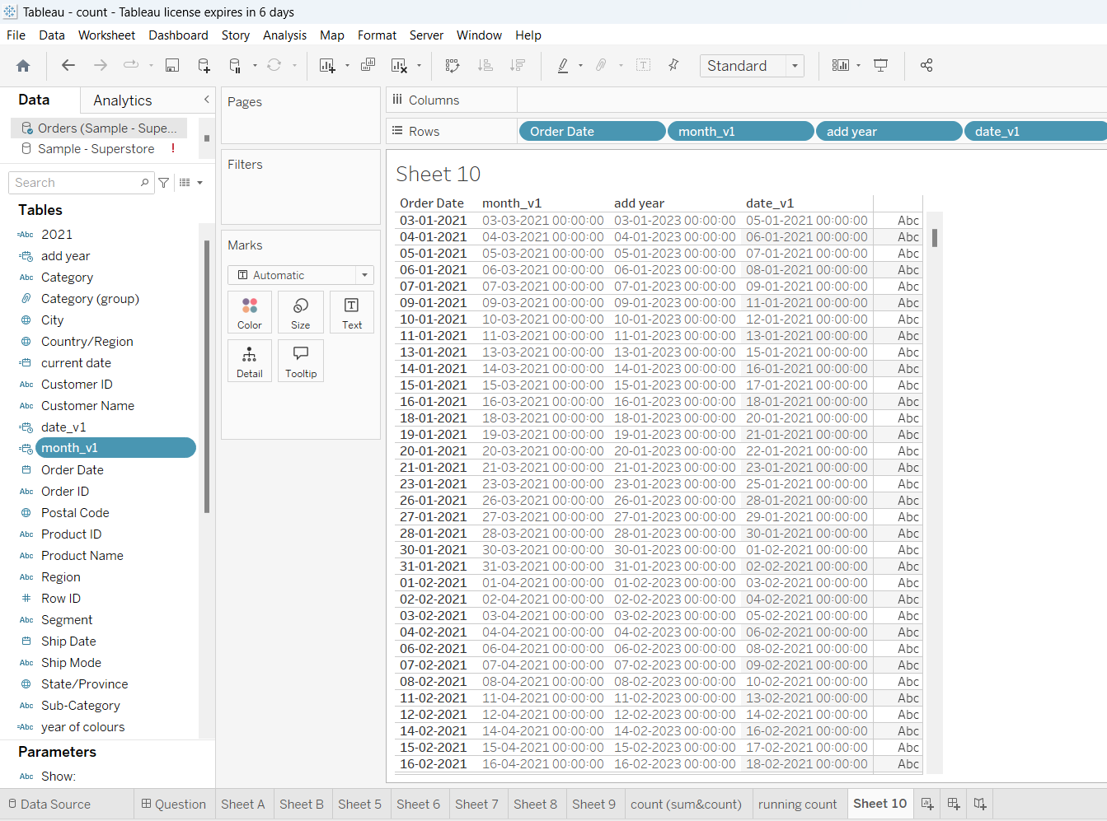

Decreasing day, month and year(-values)

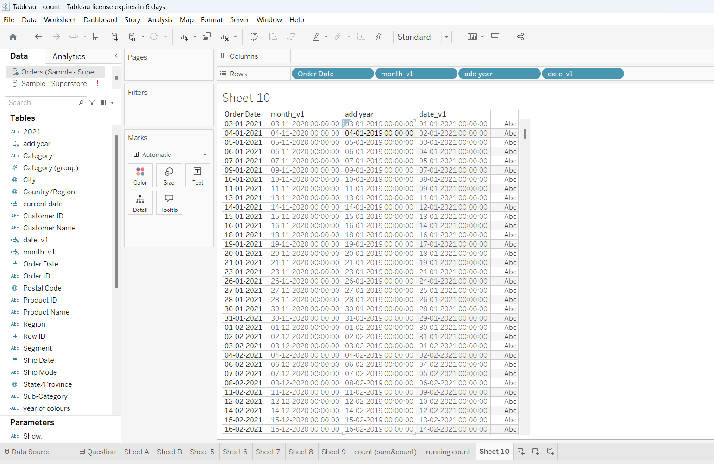

**Datediffer: --**

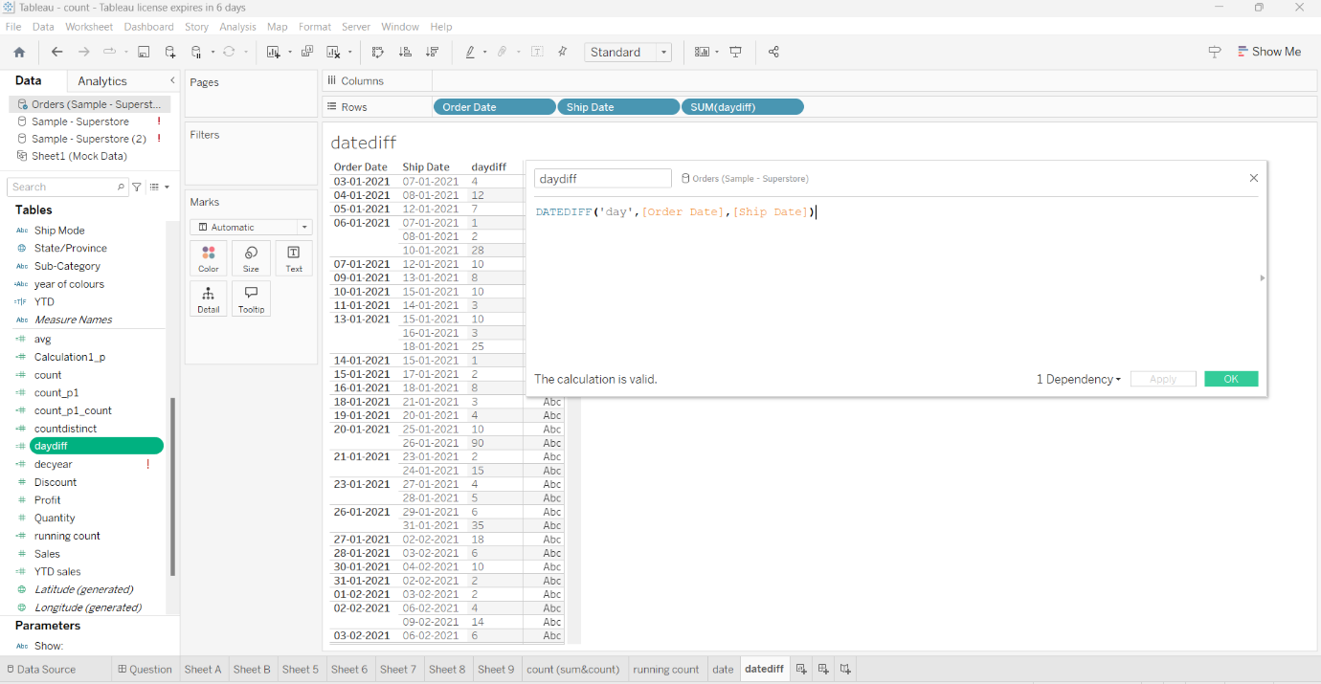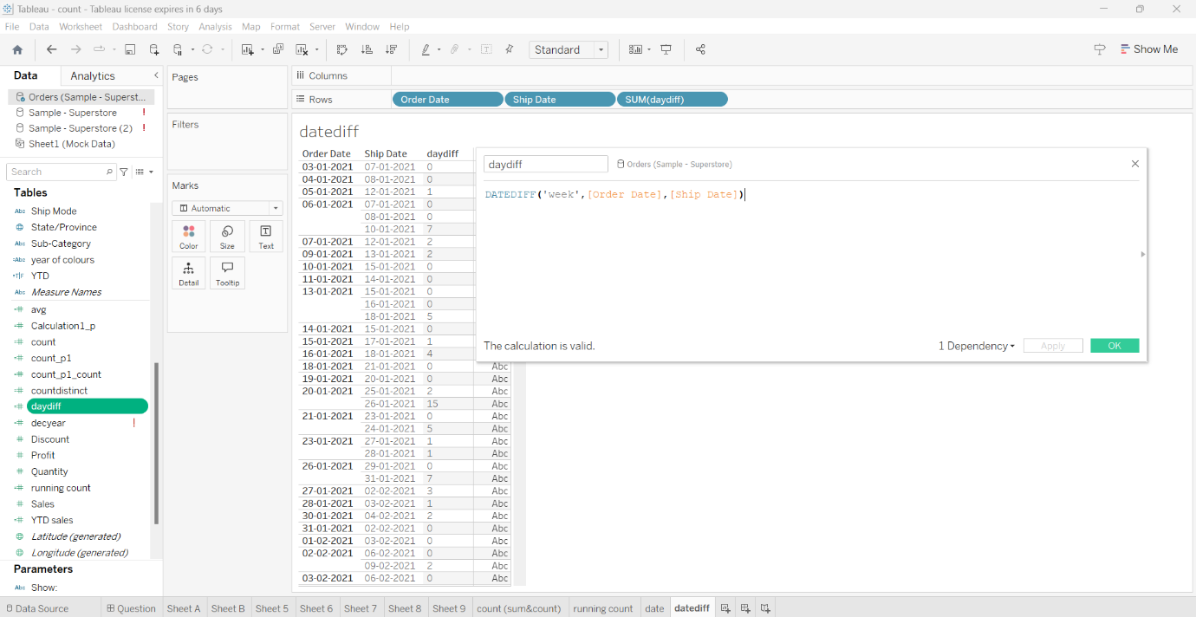

**Example 5: Difference Between Today's Date and a Given Date**

If you want to calculate the number of days between today's date and a field called [Order Date], you can use the TODAY() function in conjunction with DATEDIFF():

DATEDIFF('day', [Order Date], TODAY())

This will return the number of **days** between [Order Date] and the current date.

**Example 6: Difference in Quarters**

To calculate the difference in **quarters** between two dates:

DATEDIFF('quarter', [Start Date], [End Date])

This will return the number of quarters (3-month periods) between the two dates.

**NOW FUNCTION:**

**Example Usage:**

1. **Creating a Calculated Field:** You can create a calculated field to determine the difference in time between a specific event and the current moment. For example:

Syntax: -- DATEDIFF ('minute', [Order Date], NOW ())

This would return the number of minutes that have passed since the Order Date.

1. **Displaying Current Date and Time:** If you want to display the current date and time in your dashboard, you can create a calculated field with NOW () and place it in a text box or another element.
2. **Filtering Data:** You can use NOW () in filters to display only data that falls within a certain

Syntax: -- [Order Date] >= DATEADD ('month', -1, NOW ())

This would filter records where the order date is within the past month.

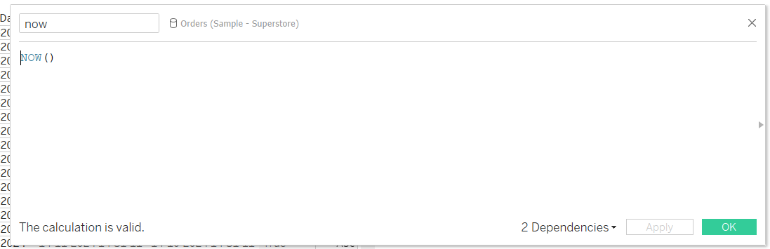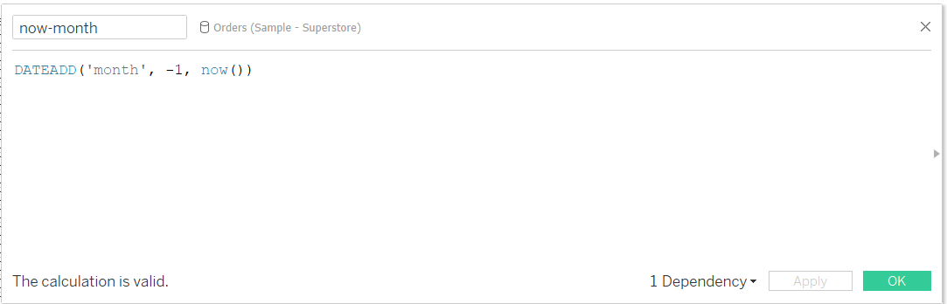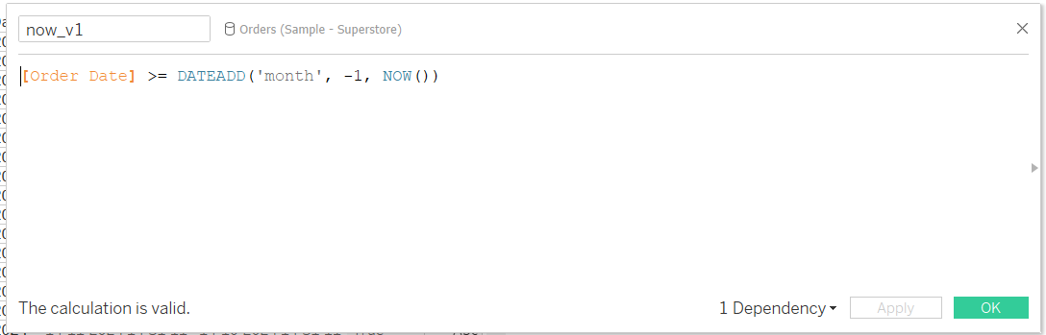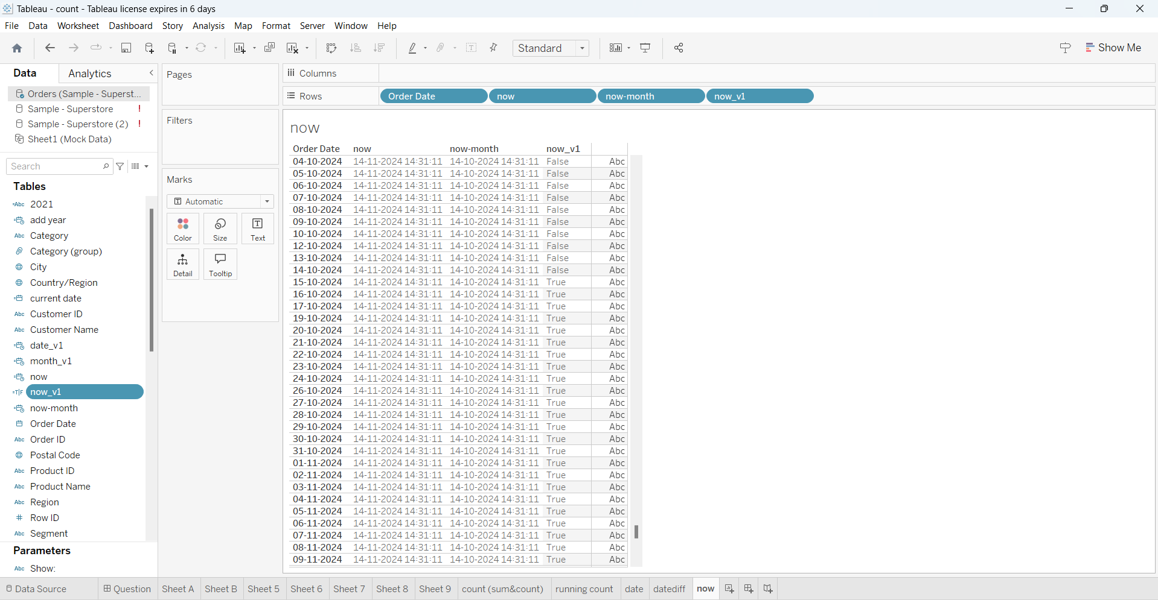

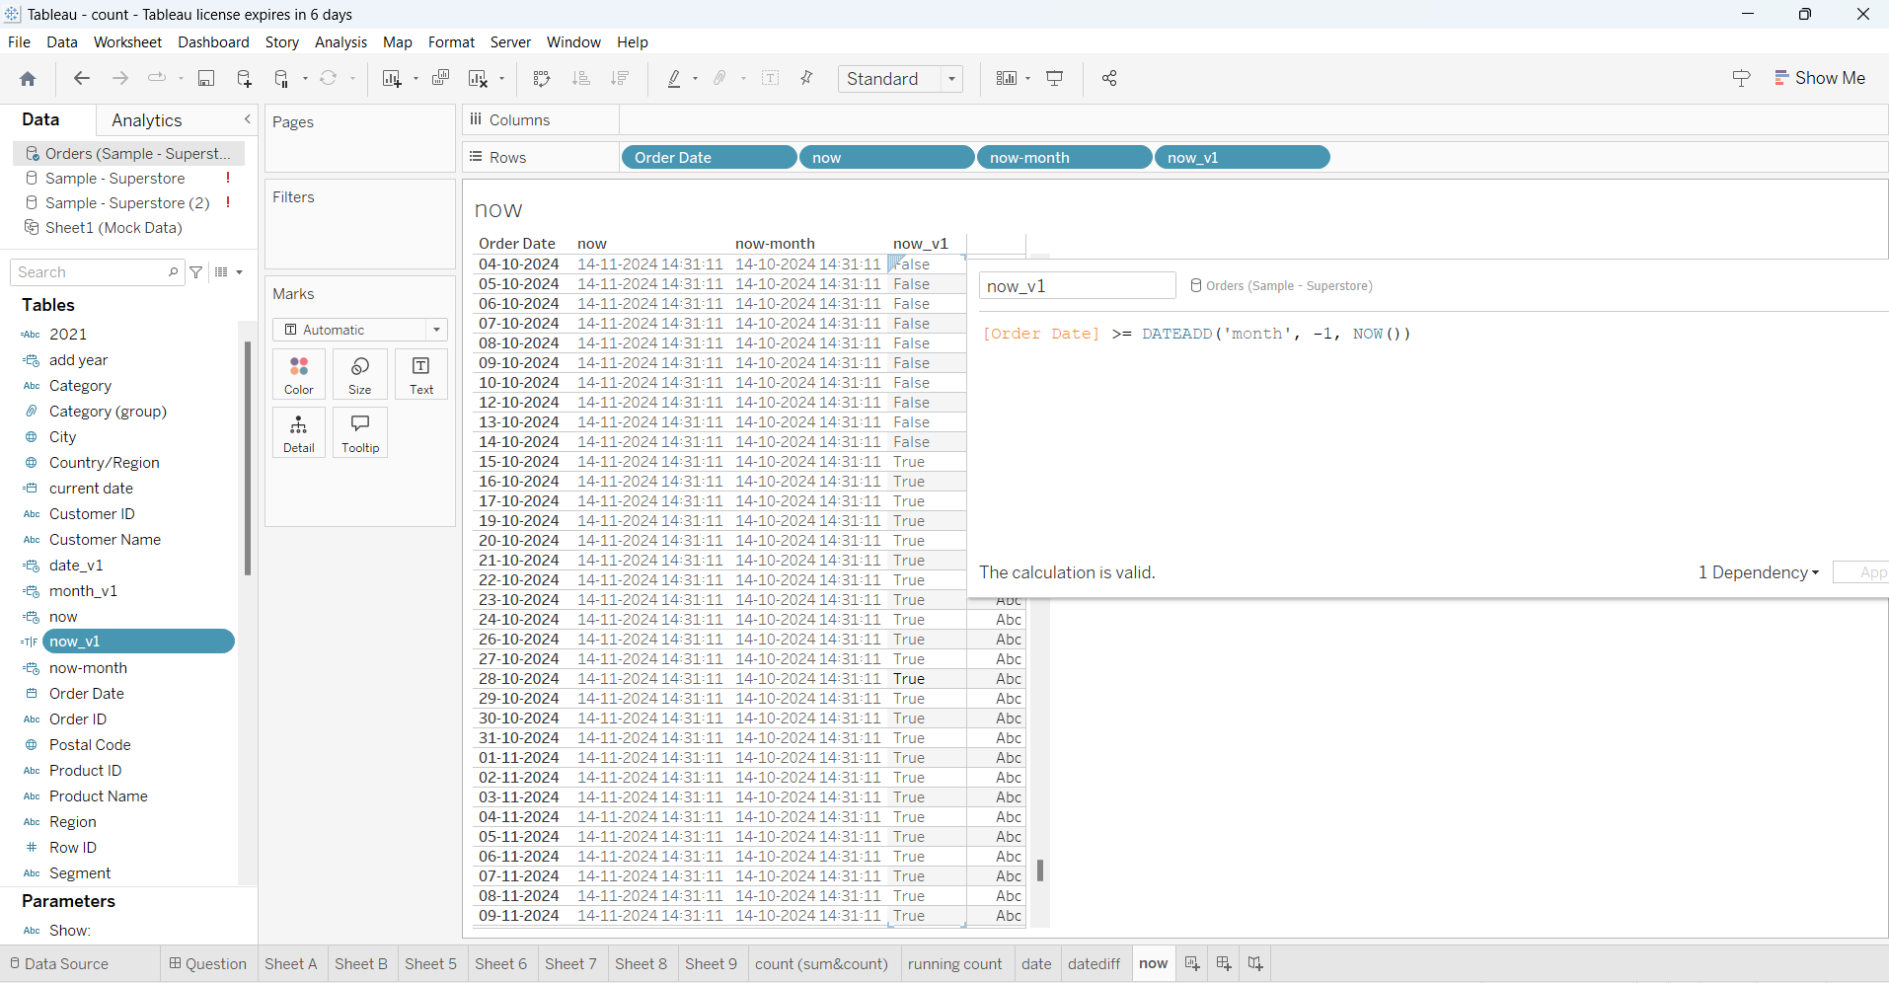

**Difference Between NOW() and TODAY():**

* NOW() gives both the **date and time**.
* TODAY() gives only the **date**, without the time portion.

**Truncdate**

**Syntax for DATETRUNC():**

DATETRUNC(date_part, date)

* **date_part**: The part of the date you want to truncate to (e.g., 'year', 'quarter', 'month', 'week', etc.).
* **date**: The date field or date expression you want to truncate.

**Common date_part Values:**

* 'year': Truncates to the first day of the year.
* 'quarter': Truncates to the first day of the quarter.
* 'month': Truncates to the first day of the month.
* 'week': Truncates to the first day of the week (typically Sunday).
* 'day': Truncates to the beginning of the day (removes the time portion).

**Examples of Using DATETRUNC() in Tableau:**

**1. Truncate to the Beginning of the Year**

If you want to truncate a date to the first day of the year, you can use:

DATETRUNC('year', [Order Date])

For example, if [Order Date] is 2024-11-14, this will return 2024-01-01.

**2. Truncate to the Beginning of the Quarter**

To truncate a date to the first day of the quarter (e.g., turning 2024-11-14 into 2024-10-01 for Q4 of 2024), use:

DATETRUNC('quarter', [Order Date])

This will return 2024-10-01 because November 14th is in the 4th quarter of the year, and DATETRUNC() rounds the date down to the start of the quarter.

**3. Truncate to the Beginning of the Month**

To truncate a date to the first day of the month (e.g., turning 2024-11-14 into 2024-11-01):

DATETRUNC('month', [Order Date])

This will return 2024-11-01, truncating to the start of November.

**4. Truncate to the Beginning of the Week**

If you want to truncate a date to the start of the week (usually Sunday by default), use:

DATETRUNC('week', [Order Date])

For example, if [Order Date] is 2024-11-14 (a Thursday), this will return 2024-11-10 (the Sunday of that week).

**5. Truncate to the Beginning of the Day**

If you want to remove the time portion of a datetime field and only keep the date:

DATETRUNC('day', [Order Date])

For example, if [Order Date] is 2024-11-14 15:30:00, this will return 2024-11-14 (removing the time).

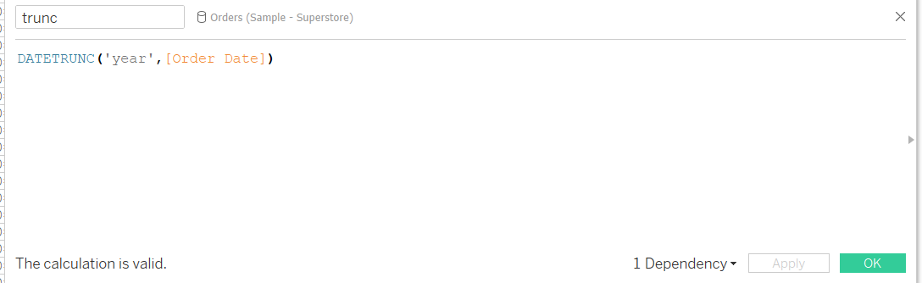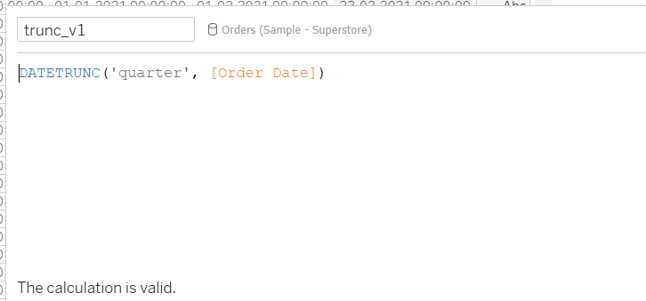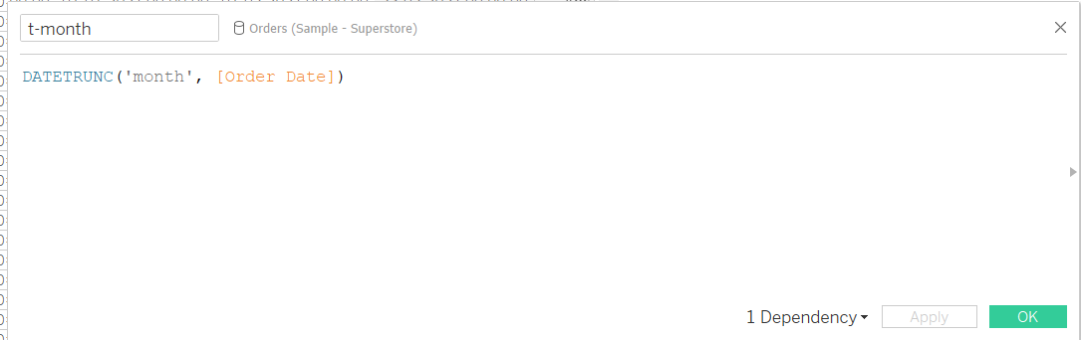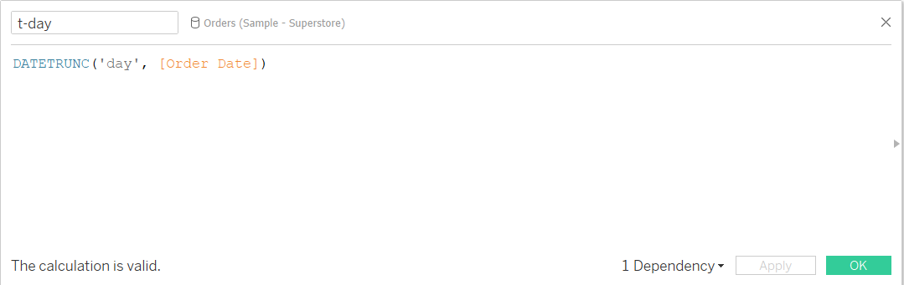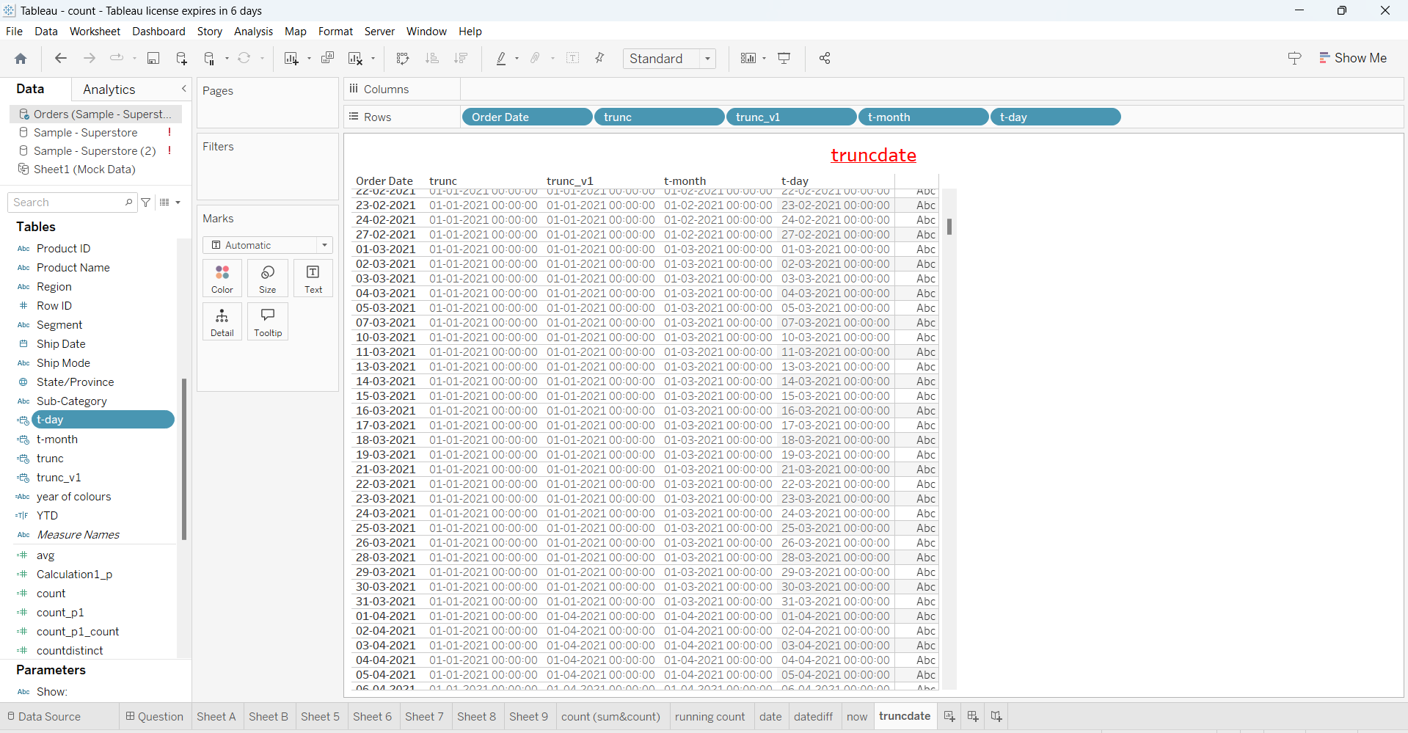

Trunc will display time stamp as all outputs.

Trunc --- changes date and month only (display same year).

Turnc_v1----every 3 months ki month will update(ex:--1,4,7,10) and date is 1 (display same year).

t-month --- month and year are same respectively orderdate (date is standard 01).

t-date--- it will display data same as order date

**contains: --**

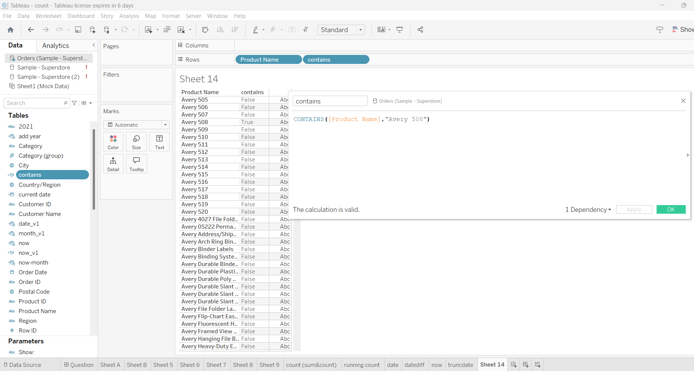

Contains with if statement:--

